**Differences between Document and Window Objects**

# ****Document Object:****

The document object represent a web page that is loaded in the browser. By accessing the document object, we can access the element in the HTML page. With the help of document objects, we can add dynamic content to our web page.

**Syntax:** document.property_name;

## **Properties of document:**

Few properties of document,

* [**domain**](https://www.geeksforgeeks.org/html-dom-domain-property/): It returns the domain name of the document server.
* [**title**](https://www.geeksforgeeks.org/html-dom-title-property/): It returns the title element of the document.
* [**head**](https://www.geeksforgeeks.org/html-dom-head-property/): It returns the head element of the document.

## **Methods of Document:**

**Syntax:** document.method_name;

Few methods of document,

* [**getElementsByTagName()**](https://www.geeksforgeeks.org/html-dom-getelementsbytagname-method/) : It returns an object containing all the elements with the specified tag names in the document as objects.
* [**querySelecto()**](https://www.geeksforgeeks.org/html-dom-queryselector-method/) **:** It returns the first element that matches a specified CSS selector(s) in the document.
* [**querySelectorAll()**](https://www.geeksforgeeks.org/html-dom-queryselectorall-method/) : It returns a collection of an element’s child elements that matches a specified CSS selector(s) in the document.

**Example:**

**First.js**

console.log(document.getElementsByTagName("p")[0].textContent);

console.log(document.querySelector("h1").textContent);

**First.js OUTPUT:**

Hello, World

THIS IS EXCELLENT

**Index.html**

<!DOCTYPE html>

<html lang="en">

<head>

    <meta charset="UTF-8">

    <meta http-equiv="X-UA-Compatible" content="IE=edge">

    <meta name="viewport" content="width=device-width, initial-scale=1.0">

    <title>Document</title>

</head>

<body>

    <h1>THIS IS EXCELLENT</h1>

   <p> Hello, World</p>

   <script src="first.js"></script>

</body>

</html>

**Index.html OUTPUT:**

THIS IS EXCELLENT

Hello, World

# ****Window Object:****

The window object is the topmost object of the DOM hierarchy. It represents a browser window or frame that displays the contents of the webpage. Whenever a window appears on the screen to display the contents of the document, the window object is created.

**Syntax:** window.property_name;

## **Properties of the window:**

Few properties of window,

* [**innerWidth**](https://www.geeksforgeeks.org/html-window-innerwidth-property/): It is used to get the width of the content area of the browser window.
* [**Name**](https://www.geeksforgeeks.org/html-window-name-property/): It contains the name of the referenced window.
* [**Navigator**](https://www.geeksforgeeks.org/html-dom-window-navigator-property/): It returns a reference to the navigator object.

## **Methods of Window:**

**Syntax:** window.method_name;

few methods of window,

* [**alert()**](https://www.geeksforgeeks.org/html-window-alert-method/): It is used to display an alert box. It displays a specified message along with an OK button and is generally used to make sure that the information comes through the user.
* [**close()**](https://www.geeksforgeeks.org/javascript-window-close-method/)**:**It is used for closing a certain window or tab of the browser which was previously opened.
* [**confirm()**](https://www.geeksforgeeks.org/javascript-window-confirm-method/)**:**It is used to display a modal dialog with an optional message and two buttons i.e. OK and Cancel. It returns true if the user clicks “OK”, and false otherwise.

**Example:**

**First.js**

console.log(window.alert("This is an alert dialog box"));

console.log(window.confirm("are you sure you want to continue"));

**First.js OUTPUT:**

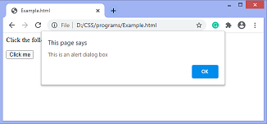

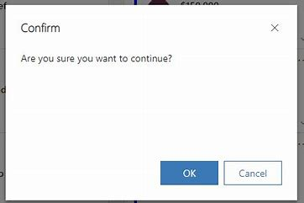

# ****Difference between document and window:****

| **document** | **window** |
| --- | --- |
| It represents any HTML document or web page that is loaded in the browser. | It represents a browser window or frame that displays the contents of the webpage. |
| It is loaded inside the window. | It is the very first object that is loaded in the browser. |
| It is the object of window property. | It is the object of the browser. |
| All the tags, elements with attributes in HTML are part of the document. | Global objects, functions, and variables of JavaScript are members of the window object. |
| We can access the document from a window using the window. | We can access the window from the window only. |
| The document is part of BOM (browser object model) and DOM (Document object model) | The window is part of BOM, not DOM. |